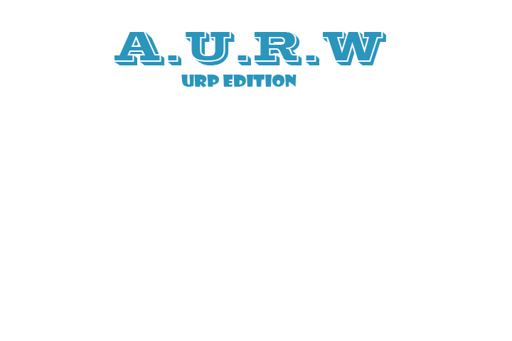

A=ABKaspo

U=Ultra

R=Realistic

W=Water

Suscribe to my chanel : <https://www.youtube.com/channel/UC6NvzQetyKK9nbfyTkBO_mA>

(the first two videos the package is declined)

package containment:

-The Water

-Water Spawner (if you’re have the version 2.0 or other)

-Terrrain Tools (by unity)

-Standar assest/skyboxes (by unity)

-The Scrpits (if you’re have the version 2.0 or other)

-the materials

================================================================================

The version lite is not recommended, because is very poor quality , but is recommendable for mobiles games. Example: for smartphone or Laptop

I personally recommend you the simple version or pro (if you’re creating a Windows/MAC/Linux)

This is a version **only compatible with URP Shader**, if you don't have it, don't use it or report the error.

written on 04/30/2021.

How To Set up?

Simple:

Go to A.U.R.W. 2021/Prefabs/

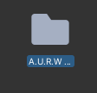

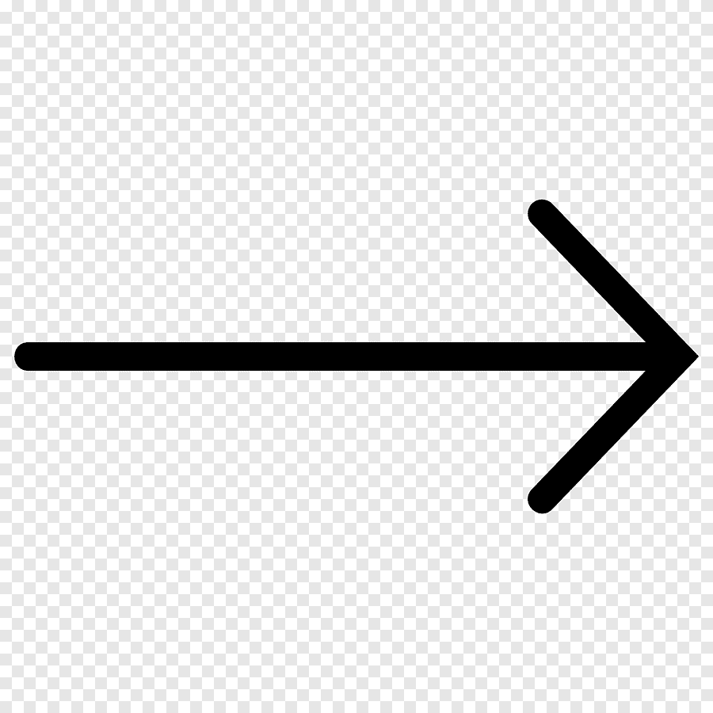

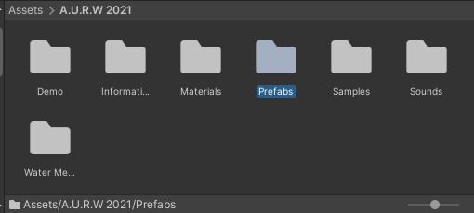



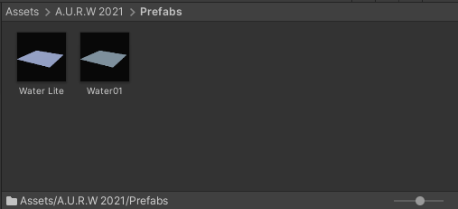

Or

Create a new plane

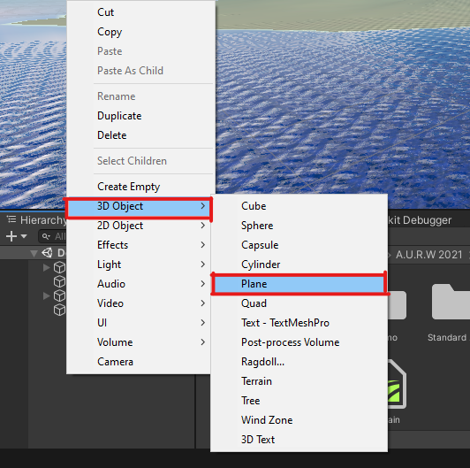



remove Mesh Collider

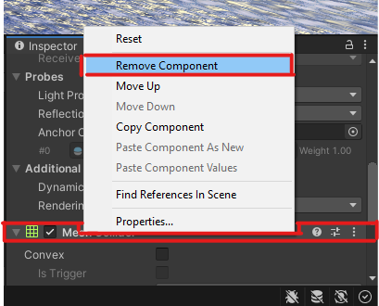



Add the material to plane

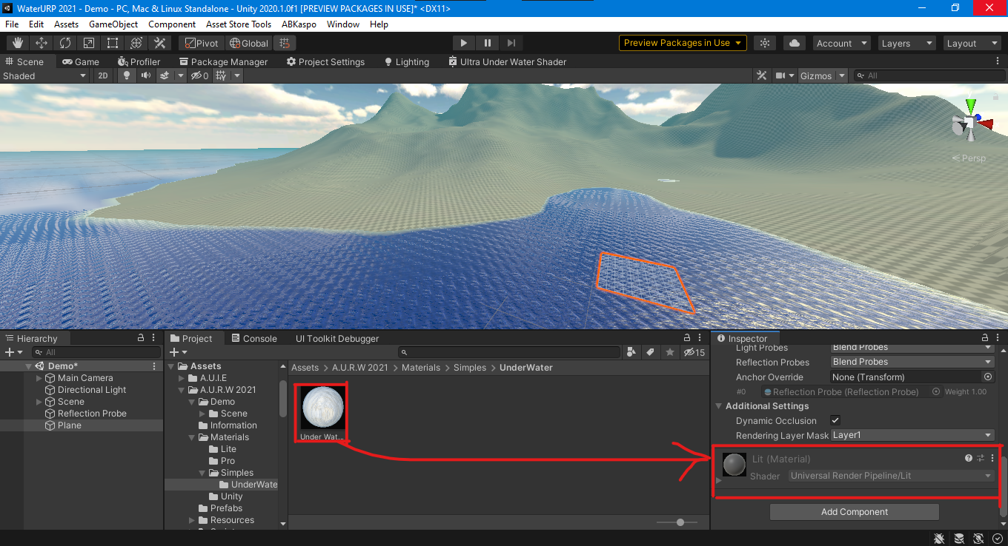



Delete the shadows

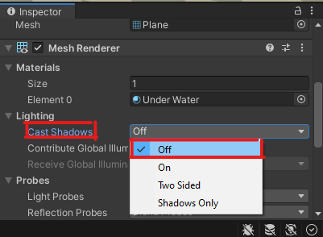



And change the mesh “Plane” to “Under”, scale XYZ axis to 100, and rotate -90 in x axis

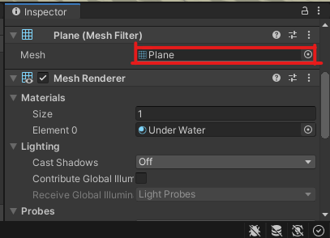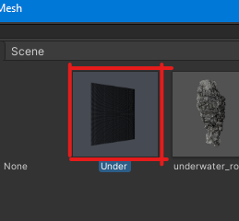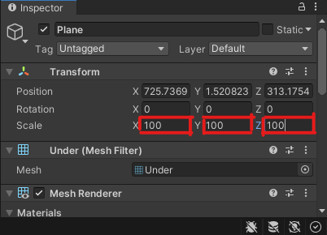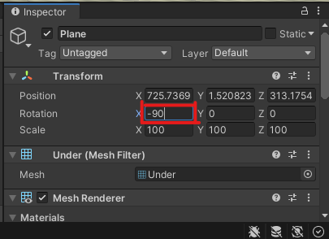

possible mistakes

if the color is pink, it is because:

- you are not using URP

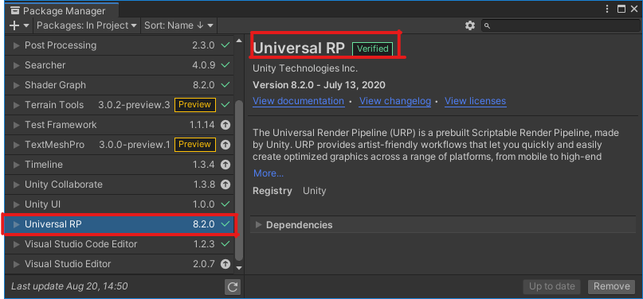

- the Scriptable Render Pipeline Settings is empty

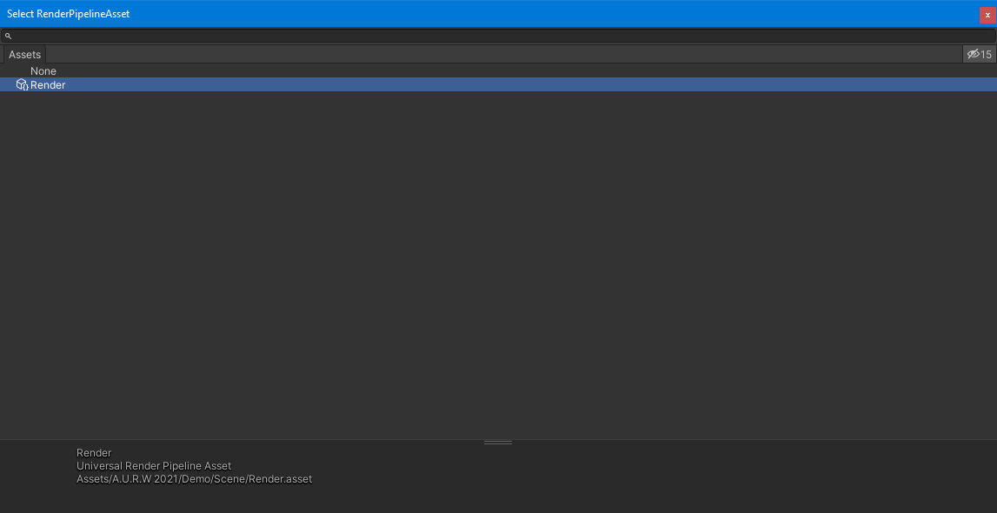

- the model does not have the material

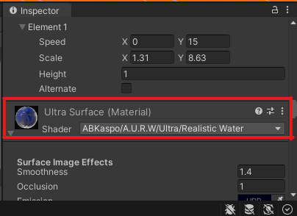

If these solutions do not work, try to locate the error and send it in the comments of the package to fix the error.

good luck creating your game :)

P.S. normally in the import of A.U.R.W. The materials do not load well and the color of the model is pink